

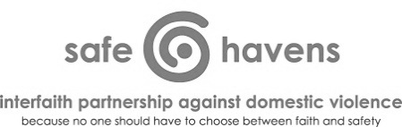

Service Provider Logo Here

|  |  |
| --- | --- |
| Pre-Registration | 7:30 – 8:15 AM |
| Registration/Refreshments | 8:00 – 8:15 AM |
| Welcome and Introductions | 8:15 – 8:45 AM |
| Activity 1: Building a Definition of Domestic Violence | 8:45 – 9:45 AM |
| --- BREAK --- | 9:45 – 10:00 AM |
| Activity 2: Learning More About Trauma | 10:00 – 10:45 AM |
| Activity 3: “Why Doesn’t She Just Leave?” | 10:45 – 11:15 AM |
| --- BREAK --- | 11:15 – 11:20 AM |
| Activity 4: How Could Sexual Violence Affect a Faith Community? | 11:20 – 11:50 AM |
| Activity 5: Sexual Violence: Can We Please Talk About It? | 11:50 AM – 12:45 PM |
| --- BREAK FOR LUNCH --- | 12:45 – 1:30 PM |
| Activity 6: The Ugly Language of Sexual Assault and Domestic Violence | 1:30 – 2:00 PM |
| Activity 7: Building Bridges Between Advocates and Faith Leaders | 2:00 – 2:45 PM |
| Activity 8: Response Skills for Faith Leaders: Initial Response to Disclosure | 2:45 – 3:00 PM |
| --- BREAK --- | 3:00 – 3:15 PM |
| Activity 9: Response Skills for Faith Leaders: Long-Term Support | 3:15 – 4:00 PM |
| Activity 10: Rural Case Study Discussion | 4:00 – 4:45 PM |
| Evaluations and Closing | 4:45 – 5:00 PM |

This document is available in word format from Safe Havens’ website at http://interfaithpartners.org/.

*© Safe Havens Interfaith Partnership Against Domestic Violence, 2014*[*www.interfaithpartners.org*](http://www.interfaithpartners.org)*,* [*info@interfaithpartners.org*](mailto:info@interfaithpartners.org)

*This project was supported by Grant No. 2011-TA-AX-K107 awarded by the Office on Violence Against Women, U.S. Department of Justice.   
The opinions, findings, conclusions, and recommendations expressed in this publication are those of the author and do not necessarily   
reflect the views of the Department of Justice, Office on Violence Against Women.*